DBMS-1002  
Making an ERD with diagrams.net (Also called: draw.io)

short line

# Instructions

If you want to use diagrams.net (draw.io) to create your ERDs, here are a few quick instructions to get you going faster:

1. Go to the website: [http://draw.io](http://draw.io/)
2. Choose where you would like to save the diagram (usually Device)
3. Choose **Create a new diagram**.
4. On the left side choose the category of **Software**
5. Pick the **Entity Relationship** option on the right (mouse over to see the names)

The easiest way to do things in this application is to just copy and paste the pre-made entities and attributes that come with the template. Stay consistent with your formatting to make it look nice! Note that the **4 cardinality symbols** are available when you click on a line between entities: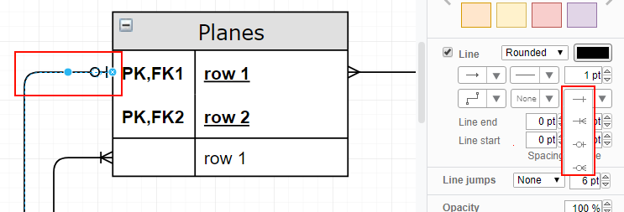

Double-clicking a line should allow you to make a **verb** on the line.

Clearly label your **Primary Keys** with **PK** and **Foreign Keys** with **FK**.

You can easily **export your ERD as a pdf** or image file to upload to DropBox: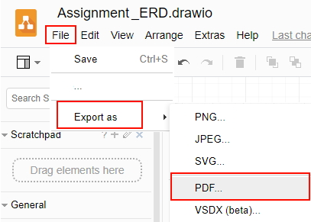

short dash